# Week 1

1A-B-Robot, Components, DOF, Joint types

* 4 DOF – for PCB assembly
* 6 DOF for a **universal** robot (3 DOF arm, 3 DOF manipulator)
* Robots are Cheaper, expendable, and always available
* Serial more common than parallel manipulator
* **Automation**: machine performs one task, **Specialised**: Performs a specific kind of task with some reconfigurability, **Universal** robot: can perform a wide variety of task --- I.e. the difference between automation and robotics is reconfiguration and flexibility
* Robotic control loop system: Actuator – forces, robot, Motion - output, sensors, controller
* **Joints**: one joint = One DOF

Joints allow mobility to the robot, the wrist give dexterity to the robot, end-effector selected for the defined task.

* + Revolute joint: allows revolution along one axis (rotation)
  + Prismatic joint: Sliding along one axis (translation)
  + Spherical joint: two revolute joint in series, thus we focus on solely revolute and prismatic joint only
* DOF is a parameter needed to describe a system, usually allowing motion in two directions, If robot has more DOF than needed it is ‘redundant’

1C-Kinematics

We know the joint variables from the sensors – Position sensors

We need:

1. The position/orientation of the robotic manipulator in 3D cartesian space

2. The position/orientation of the objects in space

* How to describe position and orientation of objects/manipulator in space?

**(composition of) transformationsb,** very important to switch frames

Forward kinematics: relative position and orientation of the end-effector to the object

**Base frame:**  Coordinate system which is attached to the base of the robot

**Tool frame:** Coordinate system which is attached to the end-effector (mobile plane)

Where, the z axis (tool) is perpendicular to the x axis (base).



For any Rotation matrix:

* The inverse is equal to the transpose (Orthogonal)
* The determinant is equal to 1 (Preserves the norm (length) of vectors)
* The norm/modulus of the rotated vector is equal to the vector itself



**General transformation** = Translation + Rotation = {Rotation matrix, Translation Vector}

Of frame {B} w.r.t. frame {A} = $\{\frac{A}{B}R, {}_{ }^{A}{P_{BORG}\}}$

**Mapping problem:** translate the position of a point from one frame to the other (i.e. change the frame of reference)

**Elementary rotations:**

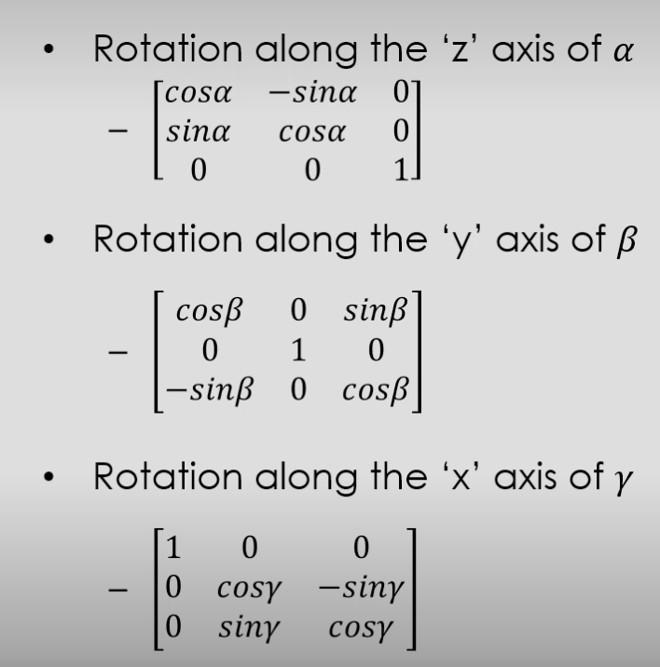

The order of any multiplicated rotations is **important**

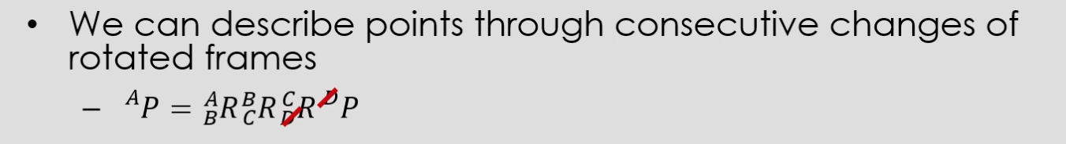

2A. Homogeneous Transforms

**Open kinematic chain:** Multiplication of all of the intermediate steps to describe the end effector position in relation to the joints or to the base.

2B. Minimal representations of Orientations (Roll, Pitch, Yaw)

Homogeneous transform has 12 variables (9 angles, 3 positions) , 6 more than needed for a 6DOF system.

**Constraints on the representation**

* The representation can be more compact, not all the variables are independent.

Not all angles are independent (**perpendicular** angles, -3 variables), and all **unit vectors** are equal to 1 (-3 variables).

So 9 variables (DOF) – 6 constraints = 3 independent variables -> 3 DOF for rotation.

3 DOF for rotation + 3 DOF for translation = 6DOF.

In total there are 24 set conventions (12 of which are fully independent):

* Roll-Pitch-Yaw (X-Y-Z Fixed)
* Euler angles (X-Y-Z)
* Skew matrices, using identity matrix

Both methods return the same rotation matrices

2B. Intrinsic Link Parameters

* The link offset is the distance between two points where the lines ai-1 and ai intersect the common axis between i-1 and i.
  + Variable for prismatic joints
  + Fixed for revolute joints
* The joint angle is theta(i) the amount of rotation about the common axis between the two links
  + Fixed for prismatic joints
  + Variable for revolute joints

**Denavit-Hartenberg** Parameters (4): fully describe/define the geometry of the manipulators. Parameters can be used to build the homogeneous transform.

Gimbal lock means we have lost 1 DOF due to the alignment of one axis with another original axis. The parameters cannot be determined independently.

* Can be avoided by adding a fourth Gimbal with an intelligent mechanism e always keeps it 90’ from the third (redundancy)
* Use quaternions to represent rotations

Special case: parallel z axis, meaning we can choose any length for d (theta , r and alpha (which is 0 due to aligned axis) stay the same)

D and theta depend on the x axis

R and alpha depend on the z axis

Week 3 – Lecture 5

Jacobian is only invertible is the matrix is n x n and there are no points of singularity (where det(A) = 0 -> Infinity.

Flip to switch rotate asap when the velocity becomes infinitely large due to points of singularity.

the Jacobian is not invertible where S1= 0, that is, when theta2= 0, pi. The points of singularity are intrinsic to the robot, and do not change when we change the frame of reference.

Lecture 6

* The difference of forces acting on a link must be null.
* The system is in static balance if the work done in force is equal to the work done in torque. Principle of virtual work
* Kineto-Static Duality links the Jacobian to force and toque respectively. Velocity kinematics and statics are linked by duality. Power = force x velocity, if power is constrained then force and velocity are not independent.

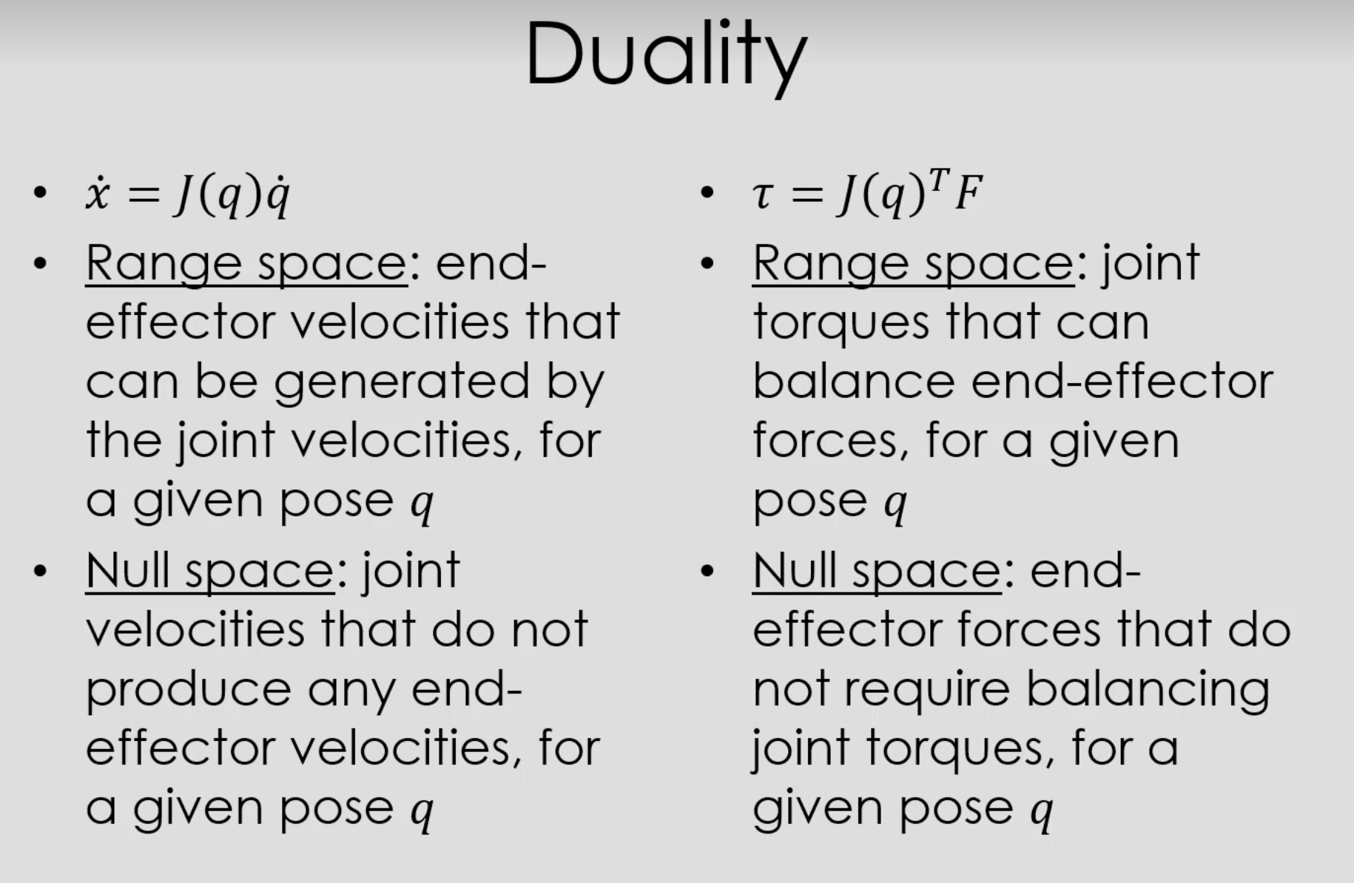Null space – J(q) all joint movement that produce no movement at the end-effector in cartesian (operational) space

Range space – End effector velocities that can be generated by the joint velocities for a given pose *q*

Manipulability: Yoshikawa or the condition number

a) Define the concepts of **accuracy** and **repeatability** in robotics

**Repeatability**: the robot can be **taught** to reach a **goal** **position** and **orientation** by **physically** moving it to the **goal** **point** and **storing** the **joint** **positions** at the goal point. To return to the goal position, the robot then uses the stored joint position values. **How** **accurately** the **robot** is able to **return** to the **taught** **position** and **orientation** is called ‘**repeatability’**.

**Accuracy:** the robot must compute how to **reach** a **never** **taught** **position** and **orientation**. How **precisely** the robot can reach the **computed** **point** is called ‘**accuracy’**.

Repeatability in industrial manipulators is usually good, whilst **accuracy** **depends** on **precise** **knowledge** of the **D-H parameters**.

b) What is the **manipulability** of a robot?

Manipulability is the **capacity** of **change** in **position** and **orientation** of the **end**-**effector** as a **function** of the **joint** **configuration**.

c) Describe how the **position** and **orientation** of the **robot** affects its **manipulability**.

The **position** and **orientation** of the **manipulator** affect the **manipulability** through the **Jacobian**. For a **unit** **norm** **velocity** in the **joint** **space**, there will be a **corresponding** **velocity** in **operational** **space**: see – answers 5.pdfThe **unit** **norm** **sphere** in **joint** **space** will be **mapped** into the **manipulability** **ellipsoid** in **operational** **space**. The **end**-**effector** has **better** **capacity** of **motion** in the **direction** of the **major** **axis** of the **ellipsoid**. Likewise, the **joint** **torque** **required** to **balance** (static equilibrium) a **unit** **norm** **force** **applied** to the **end**-**effector** (operational space) is given by: - See Answers 5.pdf

Again, the unit **norm sphere** in **joint** **space** will be **mapped** into the **manipulability** **ellipsoid** in space. The **joint torque** will have **more effect** in the **direction** of the **major axis** of the **ellipsoid**.

d) How **manipulability** is **measured**?

The two most common measures of manipulability are:

**Yoshikawa** measure of manipulability: * =56781,.1,9

And the **condition number**: : =;<=>?@,...,CD>;EF>?@,...,CD>

where G,... ,GH are the singular values of the Jacobian matrix.

Lecture 6B. Dynamics

* Gravity is accounted for by adding an upwards acceleration *g* to the base frame. gYo, Other disturbances exist e.g. vibrations.
* Calculate the speed of joints, links, and then back propagate the forces and torques.
* Assumptions made: all mass is concentrated at the end of the link, No forces on the end-effector, The base is fixed.

Lecture 7A. Trajectory planning schemes

**Joint space schemes** – describe trajectories using functions: function is continuous in velocity, zero to zero, join to move from initial position to final position with velocity equal to zero at start and finish. Velocity inverse parabolic, differentiate for position, and again for acceleration

+there are no singularities, +Simple

•Polynomials

•Linear interpolation with parabolic blends: 3 methods

In summary, joint space schemes are preferred whenever possible, because there are less issues than with **operational space** (Cartesian) schemes: 1. Trajectory partly outside of range space 2. Points of singularity 3. Trajectory not possible due to the current configuration